GYM MANAGEMENT SYSTEM

(User Profiling)

Project Number
Group Number # 8

Submitted To:
Mam Sadaf Naeem

Submission Date
24/05/26

Project Team

Sr# | Name | ID | Contribution (%)
1 | Zuhra Noreen | 231400090 | 25%
2 | Ifraim Ijaz | 231400107 | 25%
3 | Abdullah Saif | 231400116 | 25%
4 | Muneeb Akram | 231400103 | 25%

Contents
GYM MANAGEMENT SYSTEM 1
1 Introduction 1
2. User Profile 1
2.1 User Categories 1
2.2 Data Collection through Questionnaire 2
Questionnaire A — Gym Administrator 2
Questionnaire B — Fitness Trainer 3
Questionnaire C — Gym Member 4
2.3 Personas Identification and Characteristics 6
Persona 1 (Admin) 6
Persona 2 (Trainer) 7
Persona 3 (Member) 7
2.4 Usability Matrix 8
2.5 Storyboard 9
Storyboard 1 — Admin 9
Storyboard 2 — Trainer 9
Storyboard 3 — Member 10
3. Task Analysis 10
3.1 Task Organization Model (TOM) 10
3.2 Cognitive Task Analysis 12
3.2 Cognitive Task Analysis 12
3.3 Re-TOM (Revised Task Organization Model) 12
4. Usability Goals 14
5. Prototype 14
References 15

Introduction
GymPro is a mobile application made with React Native (Expo) and Firebase to help gyms manage their daily operations digitally. It supports three user roles: Admin, Trainer, and Member, with different access and features for each role. The app solves common gym problems like manual attendance, late fee collection, and poor scheduling. It includes features such as attendance tracking, payment management, class scheduling, notifications, and user management. Firebase Realtime Database is used for live data updates, while Firebase Authentication provides secure login and role-based access.

2. User Profile

2.1 User Categories
GymPro has three main user roles: Admin, Trainer, and Member. Each user has different permissions and access inside the application. Admin has full control over the system, trainers can manage attendance and schedules, while members can only access their personal information.
Category | Role in System | Access Level | Key Screens
Gym Administrator | Manages the gym | Full access | Dashboard, Users, Payments, Schedule, Attendance, Notifications, Profile
Fitness Trainer | Handles assigned members | Moderate access | Dashboard, Attendance, Schedule, Payments, Notifications, Profile
Gym Member | End user of the gym | Limited access | Dashboard, Attendance, Payments, Notifications, Profile
Users are also divided into different groups based on demographics and experience.
- Gender: Male, Female, Other
- Age Group: Teenagers, Young Adults, Adults
- Membership Type: Monthly, Quarterly, Annual

2.2 Data Collection through Questionnaire

Questionnaire A — Gym Administrator
Cognitive / Psychological
Question | Sample Response | Usability Parameter
How confident are you using digital management systems? | High | Learnability
Do you prefer mobile apps over manual record keeping? | Yes | Ease of Use
Does receiving real-time notifications help you manage tasks better? | Yes | Memory Support
How important is quick access to attendance and revenue reports? | Very Important | Efficiency
Do you feel comfortable managing multiple users through an app? | Yes | Learnability
Knowledge & Experience

Question | Sample Response | Usability Parameter
Have you used any gym management software before? | Yes | Learnability
How experienced are you with smartphone applications? | High | Learnability
Are you familiar with online payment management systems? | Yes | Learnability
How often do you use technology in your daily work? | Frequently | Efficiency
Have you previously managed attendance digitally? | Yes | Learnability

Job & Task Characteristics
Question | Sample Response | Usability Parameter
How often do you check payment records? | Daily | Efficiency
How many members do you manage daily? | More than 100 | Information Density Preference
How frequently do you send notifications to members? | Frequently | Memory Support
How often do you monitor attendance reports? | Daily | Efficiency
Do you regularly update trainer or member information? | Yes | Efficiency

Physical Characteristics
Question | Sample Response | Usability Parameter
Do you face difficulty reading small text on mobile screens? | Sometimes | Accessibility
Do you prefer large buttons and simple navigation? | Yes | Accessibility
Do you use the application while moving around the gym? | Yes | Context of Use
Do lighting conditions in the gym affect screen visibility? | Sometimes | Accessibility
Would voice or sound notifications help you while working? | Yes | Accessibility

Questionnaire B — Fitness Trainer
Cognitive / Psychological
Question | Sample Response | Usability Parameter
Do you prefer weekly schedules or daily schedules? | Daily Schedules | Efficiency
Does a simple interface help you complete tasks faster? | Yes | Ease of Use
How important is quick attendance marking during classes? | Very Important | Efficiency
Do reminders help you manage training sessions effectively? | Yes | Memory Support
Do you feel comfortable using mobile applications during workouts? | Yes | Learnability

Knowledge & Experience
Question | Sample Response | Usability Parameter
What is your comfort level with mobile applications? | High | Learnability
Have you used fitness or attendance management apps before? | Yes | Learnability
How often do you use smartphones for work-related tasks? | Frequently | Efficiency
Are you familiar with digital scheduling systems? | Yes | Learnability
Can you easily learn new application features? | Yes | Learnability

Job & Task Characteristics
Question | Sample Response | Usability Parameter
How often do you update member schedules? | Daily | Efficiency
How many attendance records do you manage daily? | 20–50 Records | Efficiency
How frequently do you check class timings? | Several Times Daily | Efficiency
Do you need instant access to member information? | Yes | Efficiency
How often do you communicate with gym members through apps? | Frequently | Efficiency

Physical Characteristics
Question | Sample Response | Usability Parameter
Do you use the app inside the gym or at home? | Inside Gym | Context of Use
Do you prefer one-hand mobile usage while training members? | Yes | Ease of Use
Does continuous app usage cause eye strain? | Sometimes | Accessibility
Do you need larger text during workout sessions? | Yes | Accessibility
Would dark mode improve visibility in gym environments? | Yes | Accessibility

Questionnaire C — Gym Member
Cognitive / Psychological
Question | Sample Response | Usability Parameter
Do fee reminders help you pay on time? | Yes | Memory Support
How important are attendance notifications for you? | Very Important | Memory Support
Do you prefer a simple and clean application interface? | Yes | Ease of Use
Does quick access to payment history improve your experience? | Yes | Efficiency
Are motivational notifications useful for gym attendance? | Yes | Memorability

Knowledge & Experience
Question | Sample Response | Usability Parameter
How often do you use fitness-related mobile applications? | Frequently | Learnability
Are you comfortable using online payment systems? | Yes | Learnability
Have you used any gym management app before? | Yes | Learnability
How experienced are you with smartphone applications? | Medium | Learnability
Can you easily navigate mobile applications without guidance? | Yes | Ease of Use

Job & Task Characteristics
Question | Sample Response | Usability Parameter
How often do you check your payment history? | Monthly | Efficiency
How frequently do you mark attendance in the gym? | Daily | Efficiency
Do you regularly check gym notifications? | Yes | Memory Support
How often do you review your membership details? | Monthly | Memorability
Do you prefer checking schedules through mobile apps? | Yes | Ease of Use

Physical Characteristics
Question | Sample Response | Usability Parameter
Do you face difficulty using your phone for long periods? | Sometimes | Accessibility
Do you prefer larger text sizes in applications? | Yes | Accessibility
Does screen brightness affect app usability for you? | Sometimes | Accessibility
Do you use the app mostly in the gym environment? | Yes | Context of Use
Would voice reminders or alerts help you manage tasks better? | Yes | Accessibility

2.3 Personas Identification and Characteristics
Three personas were created to represent the main users of GymPro. These personas help understand user goals, frustrations, and app usage patterns.

Persona 1 (Admin)
Attribute | Details
Name | Muhammad Ali
Age | 38 years
Gender | Male
Role | Gym Administrator
Education | Bachelor’s in Business Administration
Tech Literacy | Medium-High
Daily Activity | Manages gym operations, monitors attendance, handles payments, communicates with trainers
App Usage Frequency | 6–8 times per day
Goals | Monitor attendance, track revenue, manage trainers and members, send fee reminders
Pain Points | Late fee payments, difficulty tracking absent members, no real-time revenue overview
Behavior | Prefers dashboards and quick summaries, frequently checks notifications and payment updates
Preferred Device | Android smartphone
Quote | “I need to see attendance and revenue in one place.”
GymPro Screens Used | Dashboard, Users, Payments, Schedule, Notifications

Persona 2 (Trainer)
Attribute | Details
Name | Sara Khan
Age | 27 years
Gender | Female
Role | Fitness Trainer
Education | Bachelor’s in Sports Science
Tech Literacy | High
Daily Activity | Conducts training sessions, marks attendance, manages workout schedules
App Usage Frequency | 8–10 times per day
Goals | Track schedules, mark attendance, manage member lists
Pain Points | Paper-based attendance sheets, confusion in batch management
Behavior | Uses app quickly between sessions, prefers simple and fast interface
Preferred Device | iPhone
Quote | “I want a simple system to mark attendance quickly.”
GymPro Screens Used | Attendance, Schedule, Dashboard, Profile

Persona 3 (Member)
Attribute | Details
Name | Usman Raza
Age | 22 years
Gender | Male
Role | Gym Member
Education | Undergraduate Student
Tech Literacy | Medium
Daily Activity | Gym workouts, follows fitness routine, checks updates and payments
App Usage Frequency | 2–4 times per day
Goals | Check attendance, fee due dates, and payment history
Pain Points | Forgetting fee due dates, missing attendance tracking
Behavior | Uses app mainly for reminders and payment checks, prefers simple UI
Preferred Device | Android phone
Quote | “The app should remind me before my fee is due.”
GymPro Screens Used | Dashboard, Attendance, Payments, Notifications

2.4 Usability Matrix

Usability Parameter | Admin (Muhammad Ali) | Trainer (Sara Khan) | Member (Usman Raza) | Reason
Learnability | 3 | 5 | 4 | Trainer frequently uses apps and learns features quickly. Member has moderate experience. Admin already has experience so less support needed.
Efficiency | 5 | 5 | 3 | Admin and Trainer perform tasks many times daily and need fast access to features.
Memorability | 3 | 4 | 5 | Members rely heavily on reminders and notifications to remember payments and attendance.
Accessibility | 4 | 4 | 5 | Members may use the app in different environments and benefit from larger text and clear layouts.
Ease of Use | 4 | 5 | 5 | Trainer and Member prefer simple and quick interactions.
Information Density Preference | 5 | 3 | 2 | Admin requires detailed reports and analytics, while Members need only essential information.
Memory Support | 4 | 4 | 5 | Notifications, fee reminders, and attendance alerts are especially important for Members.

2.5 Storyboard
Storyboards explain how users interact with GymPro in real-life situations.

Storyboard 1 — Admin
Muhammad Ali is a 38-year-old Gym Administrator with a Bachelor's degree in Business Administration and medium-to-high technical literacy. He manages gym operations, monitors attendance, handles payments, and communicates with trainers and members. He uses GymPro 6–8 times per day through his Android smartphone. His main goals are to monitor attendance, track revenue, manage users, and send fee reminders. He prefers dashboards and quick summaries and frequently checks notifications and payment updates. His biggest challenges are late fee payments, difficulty tracking absent members, and lack of real-time revenue visibility.

Storyboard 2 — Trainer
Sara Khan is a 27-year-old Fitness Trainer with a Bachelor's degree in Sports Science and high technical literacy. She conducts training sessions, manages workout schedules, and marks attendance for gym members. She uses GymPro 8–10 times per day on her iPhone. Her goals are to track schedules, manage member lists, and mark attendance efficiently. She prefers a simple and fast interface because she often uses the application between training sessions. Her main challenges are paper-based attendance records and difficulties in managing multiple training batches.

Storyboard 3 — Member
Usman Raza is a 22-year-old undergraduate student and gym member with medium technical literacy. He uses GymPro 2–4 times per day on his Android phone. His primary goals are to check attendance records, track payment history, and receive reminders about fee due dates. He prefers a simple and easy-to-use interface. He mainly relies on notifications and reminders to stay informed about gym activities. His main challenges are forgetting fee due dates and missing attendance tracking information.

3. Task Analysis
The existing system that we examined is Gym Master Website (www.gymmaster.com)

3.1 Task Organization Model (TOM)
UC_01 Mem Member Registration & Login
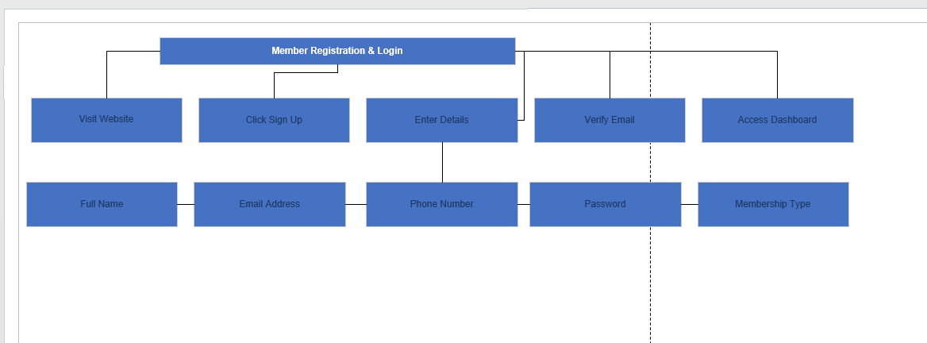

UC_02em
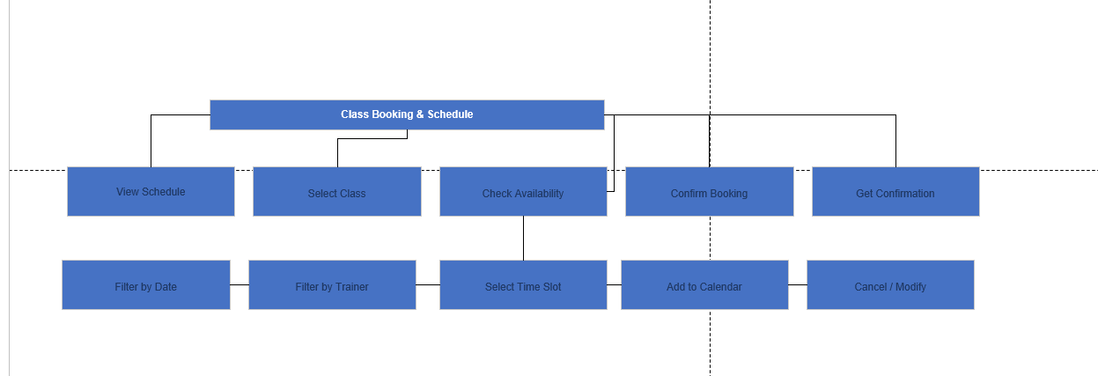
UC_03 Me
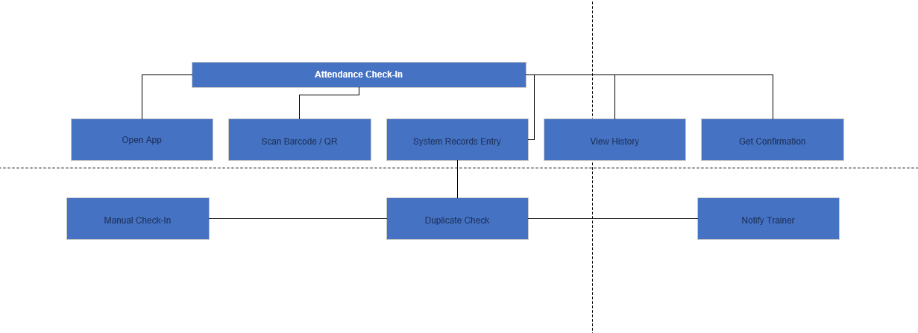 m
UC_04 Me
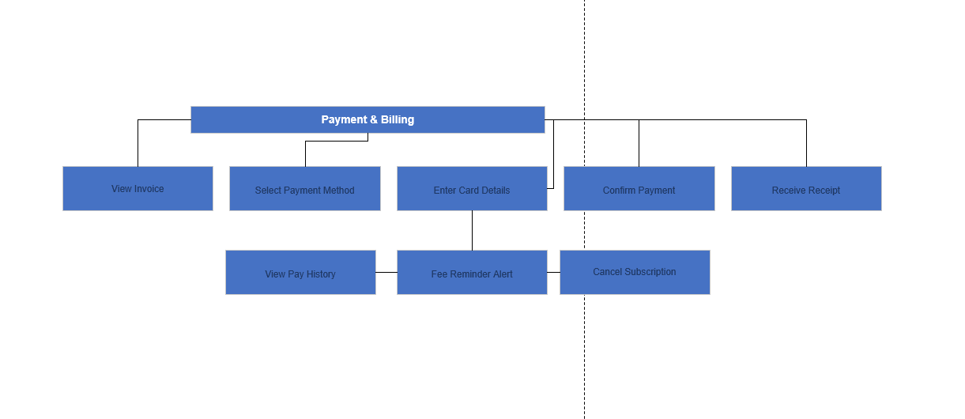 m
UC_05
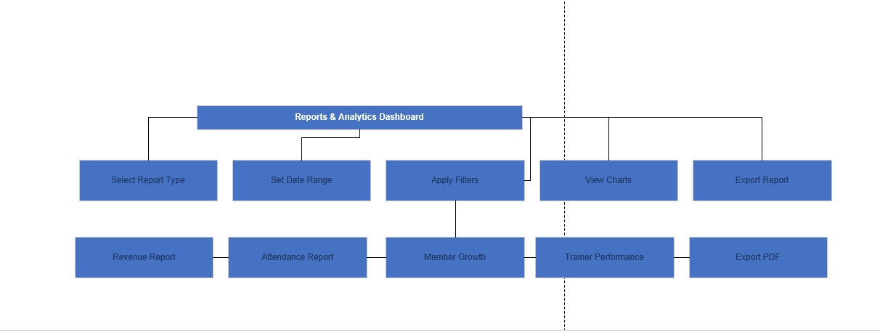
Mem ber Registration & Login

3.2 Cognitive Task Analysis
This analysis identifies common tasks, problems, and simple solutions for each user role.

3.2 Cognitive Task Analysis
Persona | Use Case | Problem Identified | Solution / Suggestion | Priority
Ali (Admin) | Member Registration | Manual registration takes time | Add bulk member registration | High
Sara (Trainer) | Class Booking | No booking cancellation alert | Add notification alerts | High
Usman (Member) | Attendance Check-In | Duplicate attendance issue | Add duplicate prevention system | Medium
Ali (Admin) | Payment & Billing | Hard to find overdue payments | Add overdue payment filter | High
Sara (Trainer) | Reports & Analytics | Cannot view member progress | Add member analytics view | Medium

3.3 Re-TOM (Revised Task Organization Model)
UC_01 M
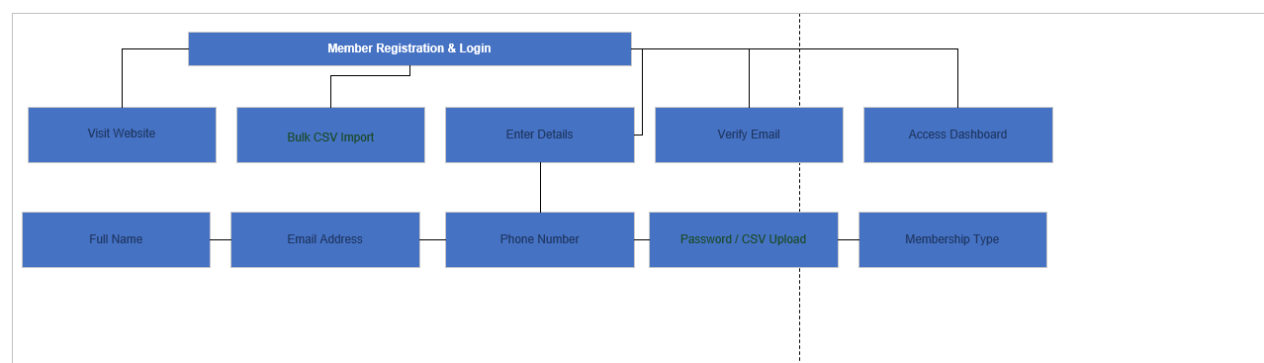
UC_02Mem
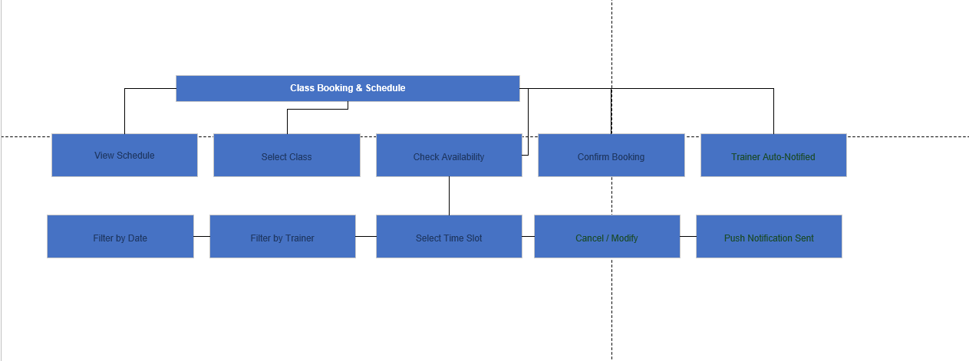
UC_03 Mem
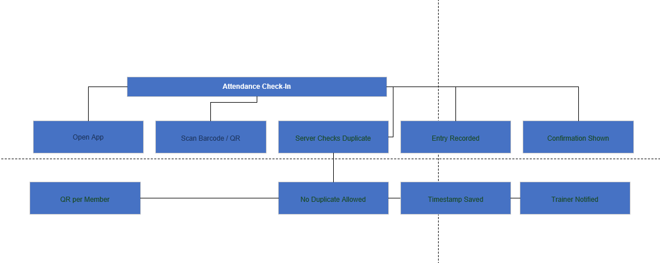
UC_04 Me
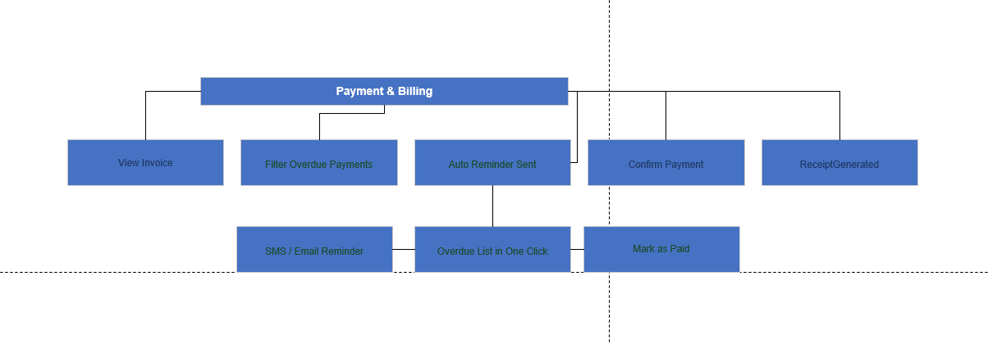 m
UC_05 M
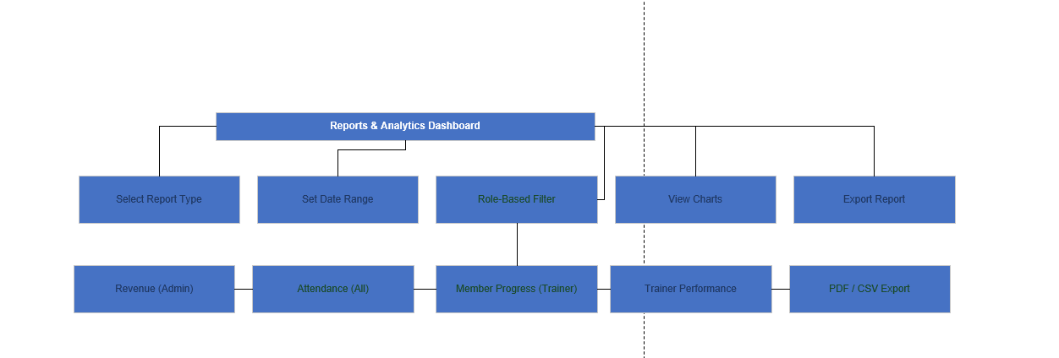 em em

4. Usability Goals
Use Case | Usability Goal | Measure | Current Baseline | Target | Type
Member Registration | Reduce member registration time | Registration completion time | 4–6 min | Less than 2 min | Quantitative
Trainer: Class Booking | Improve booking notification system | Notification response rate | 50% | 90% or higher | Quantitative
Member: Attendance Check-In | Prevent duplicate attendance | Duplicate attendance records | Around 5% | 0% duplicates | Quantitative
Admin: Payment & Billing | Improve overdue payment tracking | Payment tracking accuracy | 65% | 95% or higher | Qualitative
Trainer: Reports & Analytics | Improve access to member progress reports | User satisfaction | 3 / 5 | 4.5 / 5 or higher | Qualitative

5. Prototype

Figma Screenshot
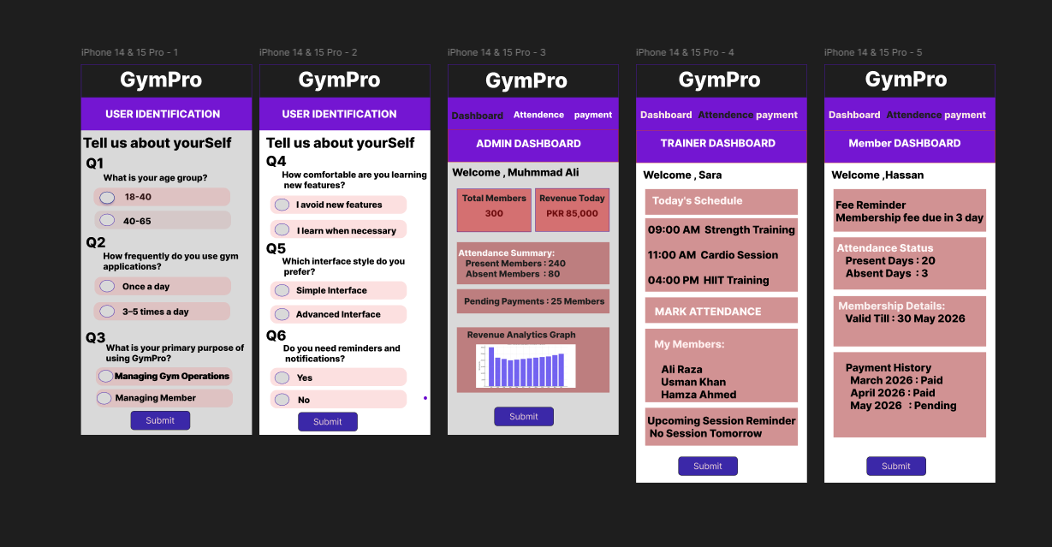

Figma Link:
https://www.figma.com/design/ir3W45Oz0k6lLowIVu5pNL/Untitled?node-id=15-189&t=FsUItJ9P20SJu7B3-0

References
- Preece, J., Rogers, Y., & Sharp, H. (2015). Interaction Design: Beyond Human-Computer Interaction (4th ed.). Wiley.
- Nielsen, J. (1993). Usability Engineering. Academic Press. ISBN: 0-12-518406-9.
- Cooper, A., Reimann, R., Cronin, D., & Noessel, C. (2014). About Face: The Essentials of Interaction Design (4th ed.). Wiley.
- Firebase Documentation. (2024). Firebase Realtime Database. https://firebase.google.com/docs/database
- Expo Documentation. (2024). Expo Router. https://docs.expo.dev/router/introduction/
- React Native Documentation. (2024). Core Components and APIs. https://reactnative.dev/docs/getting-started
- Nielsen Norman Group. (2024). Personas: An Introduction. https://www.nngroup.com/articles/personas/
- Gym Master Website (www.gymmaster.com)

Assignment Rubric
Section | Marks | Remarks
Introduction | 03 | 4-5 lines only.
User Profile | 20 | 2.1 - 2marks,  2.2, 2.4, 2.5 - 5marks,  2.3 - 3marks
Task Analysis | 20 | 3.1, 3.3 - 4marks each,  3.2 - 3marks each usecase (3*4UCs)
Usability Goals | 10 | 2.5 marks per goal (2.5*4UGs)
Prototype | 10 | equally distribute on each personas’ UI

